Final Exam

Shahar Niknazar - 316416668

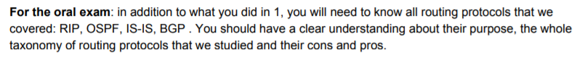

The RIP and OSPF are two interior gateway protocols (IGP) that intensively used in computer networks to specify the best routes for data transmission. RIP (Routing Information Protocol) is one of the oldest routing protocols in service, whereas OSPF (Open Shortest Patch First) serves as the most widely adopted IGP for large enterprise networks. Network admins may find themselves in a dilemma when choosing between RIP vs OSPF. So, we will present a detailed description of these two routing protocols and address key RIP vs OSPF differences.

**RIP vs OSPF: What Is RIP Protocol?**

Routing Information Protocol (RIP), is an example of distance vector routing for local networks. RIP works to deliver the whole routing table to all active interfaces in every 30 seconds. In RIP protocol, hop count is the only metrics to decide the best path to a remote network. Let’s take an example to see how RIP protocol works: Assuming, we have two paths available from the source (R1) to the destination (R7). It is clear that Path 2 will be selected by RIP protocol since it has less hop counts

Path 1: R1-R2-R4-R6-R7

Path 2: R1-R3-R5-R7

**Pros and Cons of RIP Protocol**

RIP is a great fit for small networks - It’s easy to understand and configure while also being supported by almost all routers. The hop counts of RIP is limited to 15 hops, so any router beyond that distance is considered as infinity, and hence unreachable. When implementing in a large network, RIP can create a traffic bottleneck by multicasting all the routing tables every 30 seconds, and it has very slow network convergence. Since any routing update in RIP will take up great bandwidth, the resources for critical IT processes are hence limited. Moreover, RIP doesn’t support multiple paths on the same route, which may generate more routing loops. While using fixed hop count metric to select the best routes, RIP fails to work when routes are compared based on real-time data. This causes a packet loss and overloads network operations due to repeated processes.

**RIP vs OSPF: What Is OSPF in Networking?**

OSPF (Open Shortest Path First), a link state routing protocol, is massively adopted in large enterprise networks. OSPF routing protocol collects link state information from routers in the network and determines the routing table information to forward packets. This occurs by creating a topology map for the network. Unlike RIP, OSPF only exchanges routing information when there’s a change in network topology. OSPF best fits for complex networks that comprise multiple subnet working to ease network administration and optimize traffic. It effectively calculates the shortest path with minimum network traffic when the change occurs.

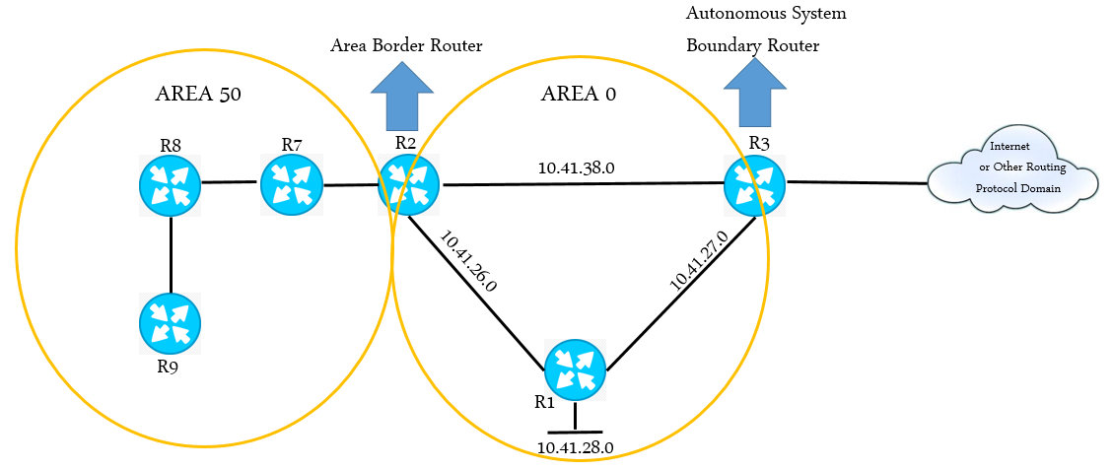

**Pros and Cons of OSPF Protocol**

Using OSPF protocol demands advanced knowledge about complex networks. So OSPF routing protocol allows routers to calculate routes based on incoming requests. Unlike RIP protocol that has only 15 hops at most, OSPF has no limitations in hop count. So OSPF converges faster than RIP, and has better load balancing. The drawbacks of OSPF, however, is that it doesn’t scale when there are more routers added to the network. And this lack of scalability in OSPF makes it unsuitable for routing across the Internet.

**RIP vs OSPF: What Is the Difference?**

The RIP and OSPF are the IGP that routing information within an autonomous system, and RIP vs OSPF differs in many aspects.



**Routing Protocol Type:**The RIP is a distance vector protocol whereas the OSPF is a link state protocol. A distance vector protocol uses the distance or hop counts to determine the transmission path. The link state protocol analyzes different sources like the speed, cost and path congestion while identifying the shortest path.

**Network table construction:**The RIP requests the routing table from the devices around the router that uses RIP. Then the router consolidated that information and constructs its own routing table. This table is sent to those neighboring devices at a regular interval and the consolidated routing table of the router is updated. In OSPF, the router consolidates routing table by getting only required information from the neighboring devices. It never gets the entire routing table of the devices and the routing table construction is really simpler.

**Hop Count Restriction:**The RIP allows only up to 15 hops, whereas in OSPF protocol, there is no such restriction.

**Algorithm used:**The RIP routing protocol uses the distance vector algorithm whereas the OSPF uses the shortest path algorithm Dijkstra to determine the transmission routes.

**Network classification:**In RIP, the networks are classified as areas and tables. In OSPF, the networks are classified as areas, sub areas, autonomous systems and backbone areas.

**Complexity level:**The RIP is relatively simpler whereas the OSPF is much more complex.

**RIP vs OSPF Application:**The RIP suits better for smaller networks as it has hop count restrictions. The OSPF serves great for larger networks.

Other RIP vs OSPF differences are presented in the chart below.

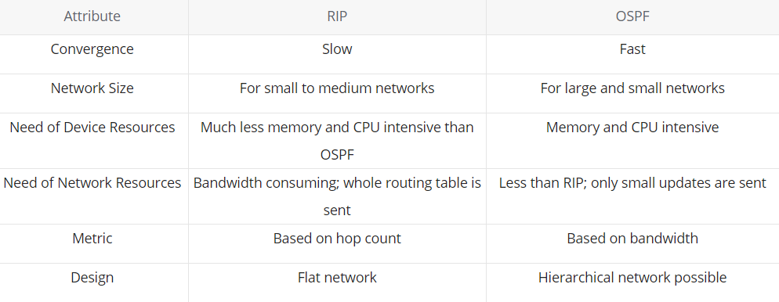

**Conclusion**

After comparing RIP vs OSPF differences, it’s clear that RIP is ideal for small networks that are simple and non-hierarchical, whereas OSPF fits best for large and hierarchical enterprise networks. In a complex network, you may have multiple routing protocols operating simultaneously.

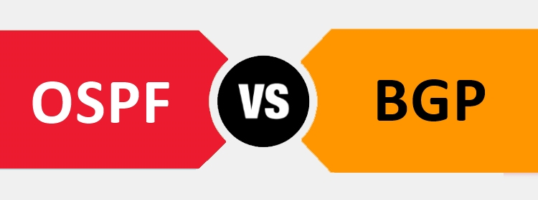

Both OSPF (Open Shortest Path First) and BGP (Border Gateway Protocol) are routing protocols that make routing decisions across the Internet. They represent a set of rules or algorithms that instruct network routers on how to communicate with each other, so they can redirect traffic to the best path. OSPF vs BGP, what are their differences? How to choose between the two?

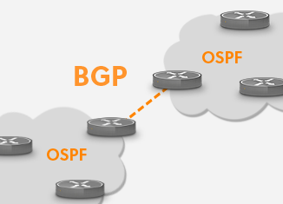

## OSPF vs BGP: What Are the Differences?

The main difference between OSPF and BGP is that OSPF is an intra-domain routing protocol using link state routing, and the routing operation is performed inside an autonomous system while BGP is the inter-domain routing protocol that uses path vector routing, with the routing operations performed between two autonomous systems. Some other distinctions between OSPF vs BGP include:

* Configuration: OSPF is easily-configured while BGP configuration is a lot more complex.
* Convergence rate: OSPF can achieve convergence (the time a router takes to share and update the latest routing information) faster. In contrast, the BGP has a slow convergence rate.
* Network topology or design: OSPF is a type of hierarchical network topology or design while BGP is a type of mesh topology or design.
* Resources requirement: OSPF requires intensive use of memory and CPU resources. With BGP on the other hand, the size of the routing table dictates the required device resources.
* Scale: BGP is more flexible and scalable than OSPF and it is also used on a larger network.
* Preferred path: OSPF is used to determine the fastest route while BGP puts emphasis on determining the best path.
* Protocol: In OSPF, internet protocol is used. While in BGP, transmission control protocol is used.

Here is a chart summarizing the differences of OSPF vs BGP:

## 

## OSPF vs BGP: How to Choose?

If you are conducting internal routing, such as routing within a site, company, or campus, you will want to use OSPF. BGP is typically needed at a site edge, where you route out to the public internet. If you are looking at building in-site with multiple homes, you might want to consider BGP. Moreover, for enterprise network, pick OSPF as your routing protocol. As a developed and mature protocol, OSPF is supported by the vast majority of network vendors. As a service provider, adopt the BGP to carry your customers' routes. Generally, most of the service providers would use IGP to carry Infrastructure IPs and BGP to carry customer routes.

Although BGP is used between multiple autonomous systems as an external routing protocol, many network giants like Microsoft and Facebook would use it internally – in this case, BGP is typically fit for very large networks which OSPF fails to handle. One of the many reasons that BGP does not function well as an internal gateway protocol is that it is very slow to converge.

**IS-IS**

IS-IS is a link-state routing protocol, which means that the routers exchange topology information with their nearest neighbors. The topology information is flooded throughout the AS, so that every router within the AS has a complete picture of the topology of the AS. This picture is then used to calculate end-to-end paths through the AS, normally using a variant of the Dijkstra algorithm. Therefore, in a link-state routing protocol, the next hop address to which data is forwarded is determined by choosing the best end-to-end path to the eventual destination.

The main advantage of a link state routing protocol is that the complete knowledge of topology allows routers to calculate routes that satisfy particular criteria. This can be useful for traffic engineering purposes, where routes can be constrained to meet particular quality of service requirements. The main disadvantage of a link state routing protocol is that it does not scale well as more routers are added to the routing domain. Increasing the number of routers increases the size and frequency of the topology updates, and also the length of time it takes to calculate end-to-end routes. This lack of scalability means that a link state routing protocol is unsuitable for routing across the Internet at large, which is the reason why IGPs only route traffic within a single AS.

IS-IS was originally devised as a routing protocol for CLNP, but has been extended to include IP routing; the extended version is sometimes referred to as Integrated IS-IS.

Each IS-IS router distributes information about its local state (usable interfaces and reachable neighbors, and the cost of using each interface) to other routers using a Link State PDU (LSP) message. Each router uses the received messages to build up an identical database that describes the topology of the AS.

From this database, each router calculates its own routing table using a Shortest Path First (SPF) or Dijkstra algorithm. This routing table contains all the destinations the routing protocol knows about, associated with a next hop IP address and outgoing interface.

* The protocol recalculates routes when network topology changes, using the Dijkstra algorithm, and minimises the routing protocol traffic that it generates.
* It provides support for multiple paths of equal cost.
* It provides a multi-level hierarchy (two-level for IS-IS) called "area routing," so that information about the topology within a defined area of the AS is hidden from routers outside this area. This enables an additional level of routing protection and a reduction in routing protocol traffic.
* All protocol exchanges can be authenticated so that only trusted routers can join in the routing exchanges for the AS.

## Comparison with OSPF[[edit](https://en.wikipedia.org/w/index.php?title=IS-IS&action=edit&section=4)]

Both IS-IS and [Open Shortest Path First](https://en.wikipedia.org/wiki/Open_Shortest_Path_First) (OSPF) are link-state protocols, and both use the same [Dijkstra algorithm](https://en.wikipedia.org/wiki/Dijkstra%27s_algorithm) for computing the best path through the network. As a result, they are conceptually similar. Both support [variable length subnet masks](https://en.wikipedia.org/wiki/Variable_length_subnet_mask), can use [multicast](https://en.wikipedia.org/wiki/Multicast) to discover neighboring [routers](https://en.wikipedia.org/wiki/Router_(computing)) using *hello packets*, and can support authentication of routing updates.

While OSPF was natively built to route IP and is itself a [Layer 3](https://en.wikipedia.org/wiki/Network_Layer) protocol that runs on top of IP, IS-IS is an OSI [Layer 2](https://en.wikipedia.org/wiki/Data_link_layer) protocol.[[4]](https://en.wikipedia.org/wiki/IS-IS#cite_note-4) It is at the same layer as [Connectionless Network Protocol](https://en.wikipedia.org/wiki/Connectionless_Network_Protocol) (CLNP). The widespread adoption of IP may have contributed to OSPF's popularity. IS-IS does not use IP to carry routing information messages. OSPF version 2, on the other hand, was designed for [IPv4.](https://en.wikipedia.org/wiki/Internet_Protocol_version_4) IS-IS is neutral regarding the type of network addresses for which it can route. This allowed IS-IS to be easily used to support [IPv6](https://en.wikipedia.org/wiki/IPv6). To operate with IPv6 networks, the OSPF protocol was rewritten in OSPF v3 (as specified in [RFC 2740](https://tools.ietf.org/html/rfc2740)).

Both OSPF and IS-IS routers build a topological representation of the network. This map indicates the subnets which each IS-IS router can reach, and the lowest-cost (shortest) path to a subnet is used to forward traffic.

IS-IS differs from OSPF in the way that "areas" are defined and routed between. IS-IS routers are designated as being: Level 1 (intra-area); Level 2 (inter area); or Level 1–2 (both). Routing information is exchanged between Level 1 routers and other Level 1 routers of the same area, and Level 2 routers can only form relationships and exchange information with other Level 2 routers. Level 1–2 routers exchange information with both levels and are used to connect the inter area routers with the intra area routers.

In OSPF, areas are delineated on the interface such that an area border router (ABR) is actually in two or more areas at once, effectively creating the borders between areas inside the ABR, whereas in IS-IS area borders are in between routers, designated as Level 2 or Level 1–2. The result is that an IS-IS router is only ever a part of a single area.

IS-IS also does not require Area 0 (Area Zero) to be the backbone area through which all inter-area traffic must pass. The logical view is that OSPF creates something of a spider web or star topology of many areas all attached directly to Area Zero and IS-IS, by contrast, creates a logical topology of a backbone of Level 2 routers with branches of Level 1–2 and Level 1 routers forming the individual areas.

IS-IS also differs from OSPF in the methods by which it reliably floods topology and topology change information through the network. However, the basic concepts are similar.[[*citation needed*](https://en.wikipedia.org/wiki/Wikipedia:Citation_needed)]

OSPF has a larger set of extensions and optional features specified in the protocol standards. However, IS-IS is easier to expand: its use of [type-length-value](https://en.wikipedia.org/wiki/Type-length-value) (TLV) data allows engineers to implement support for new techniques without redesigning the protocol. For example, in order to support IPv6, the IS-IS protocol was extended to support a few additional TLVs, whereas OSPF required a new protocol draft (OSPFv3). In addition to that, IS-IS is less "chatty" and can scale to support larger networks. Given the same set of resources, IS-IS can support more routers in an area than OSPF. This has contributed to IS-IS as an ISP-scale protocol.[[*citation needed*](https://en.wikipedia.org/wiki/Wikipedia:Citation_needed)]

The TCP/IP implementation, known as "Integrated IS-IS" or "Dual IS-IS", is described in [RFC 1195](https://tools.ietf.org/html/rfc1195).